**Event Reminder App**

**Contributors:**

* Sahana Rao PS (PS: 99002542)
* Sk Md Sohel (PS: 99002491)
* Shruti Hazra (PS: 99002643)

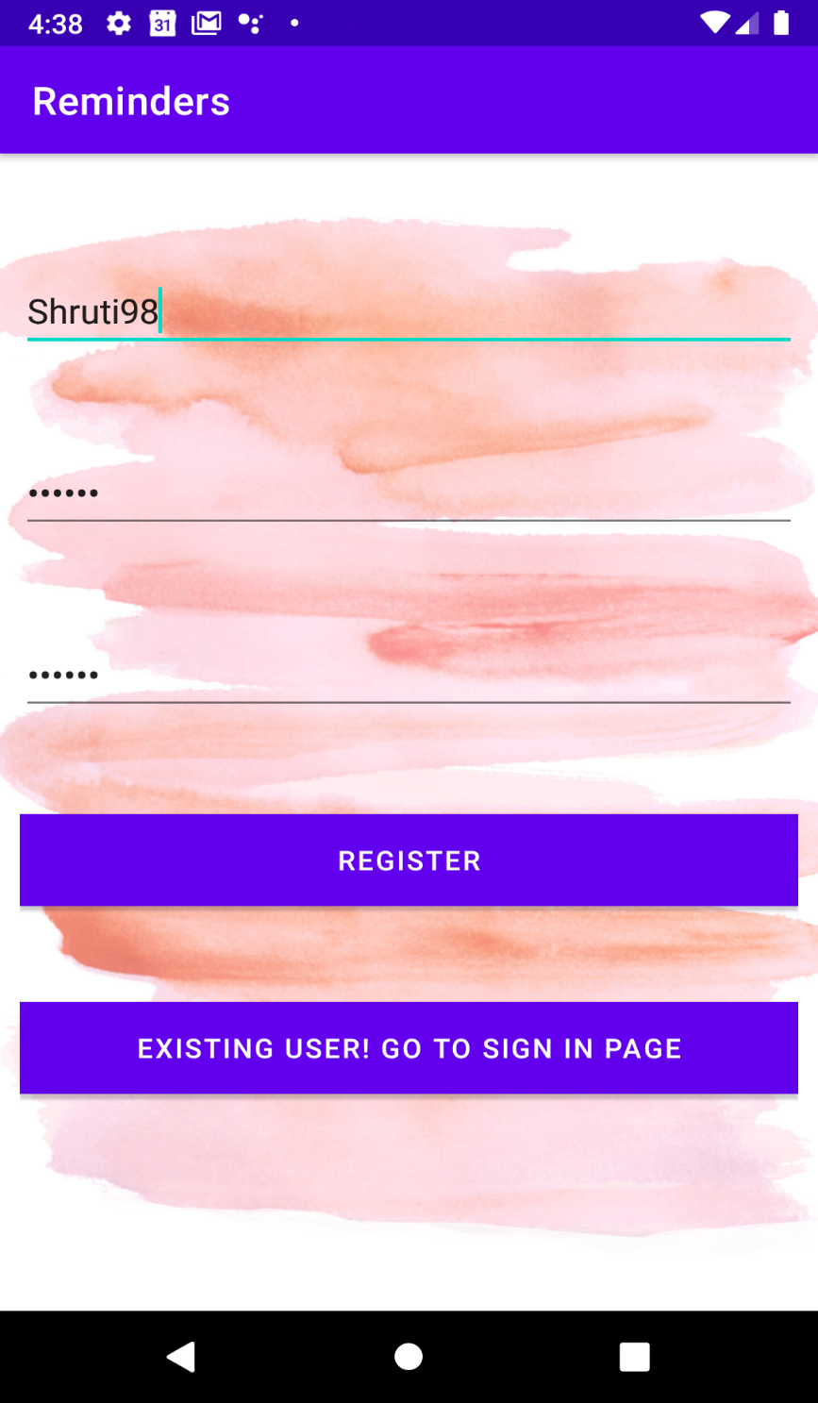**Screenshots:**

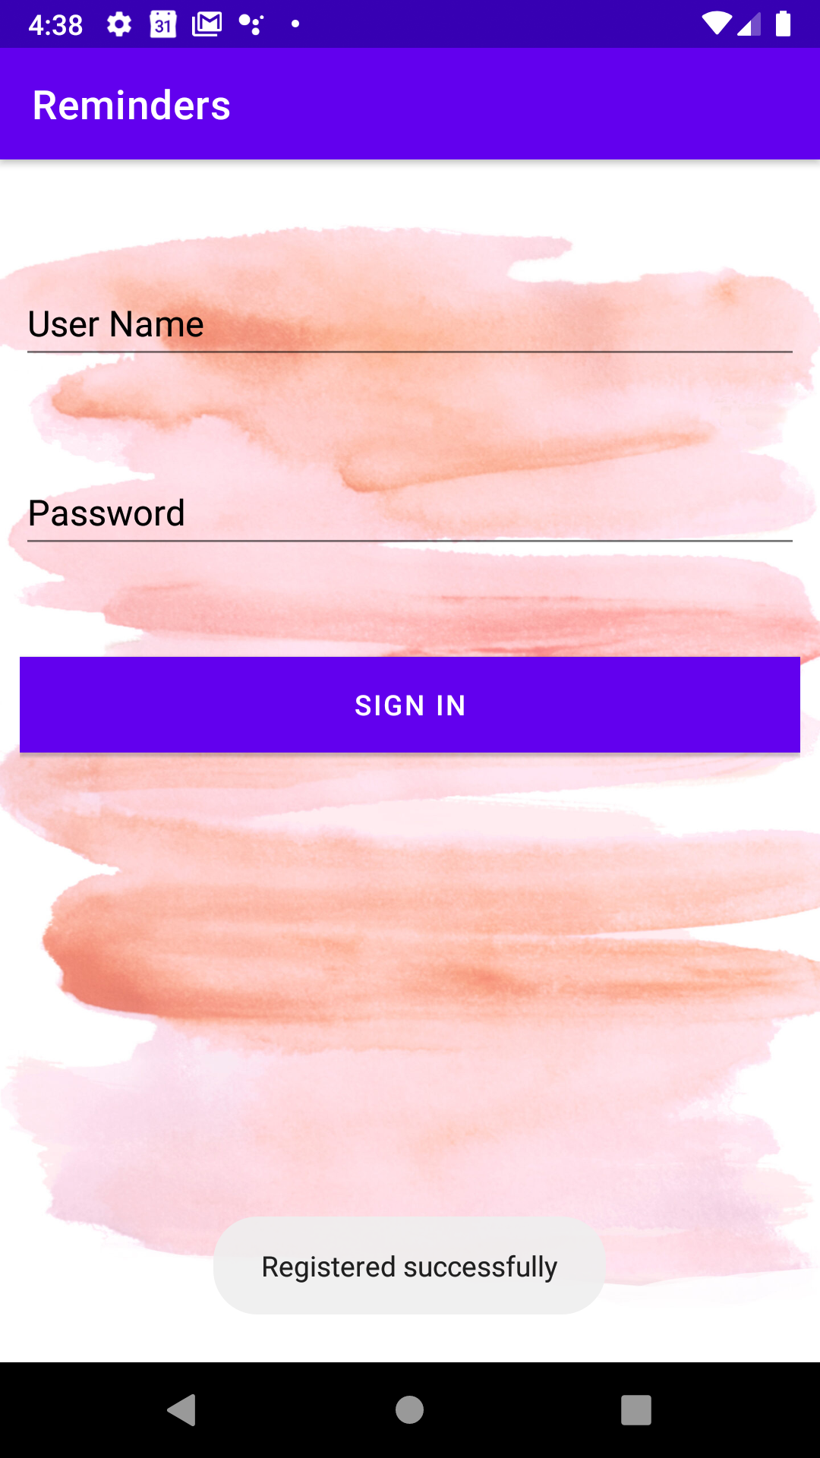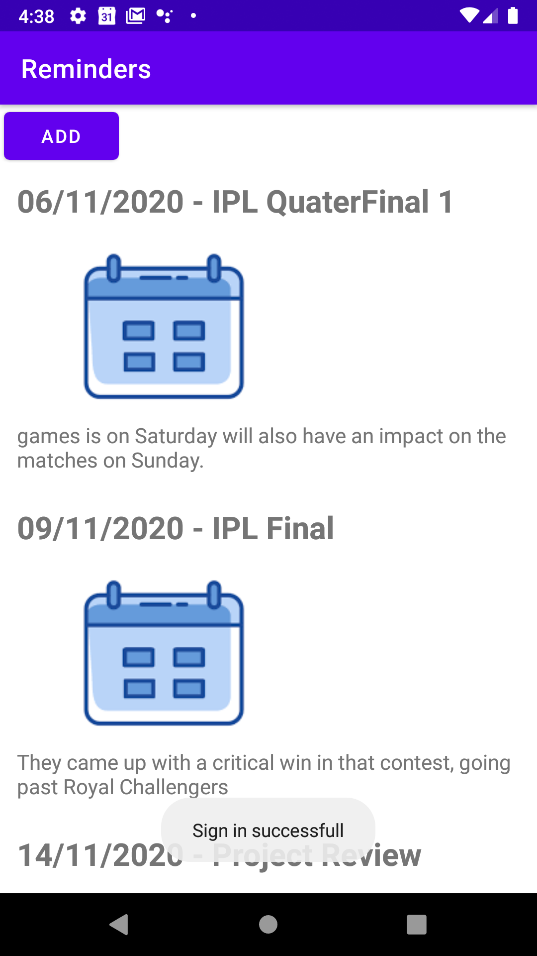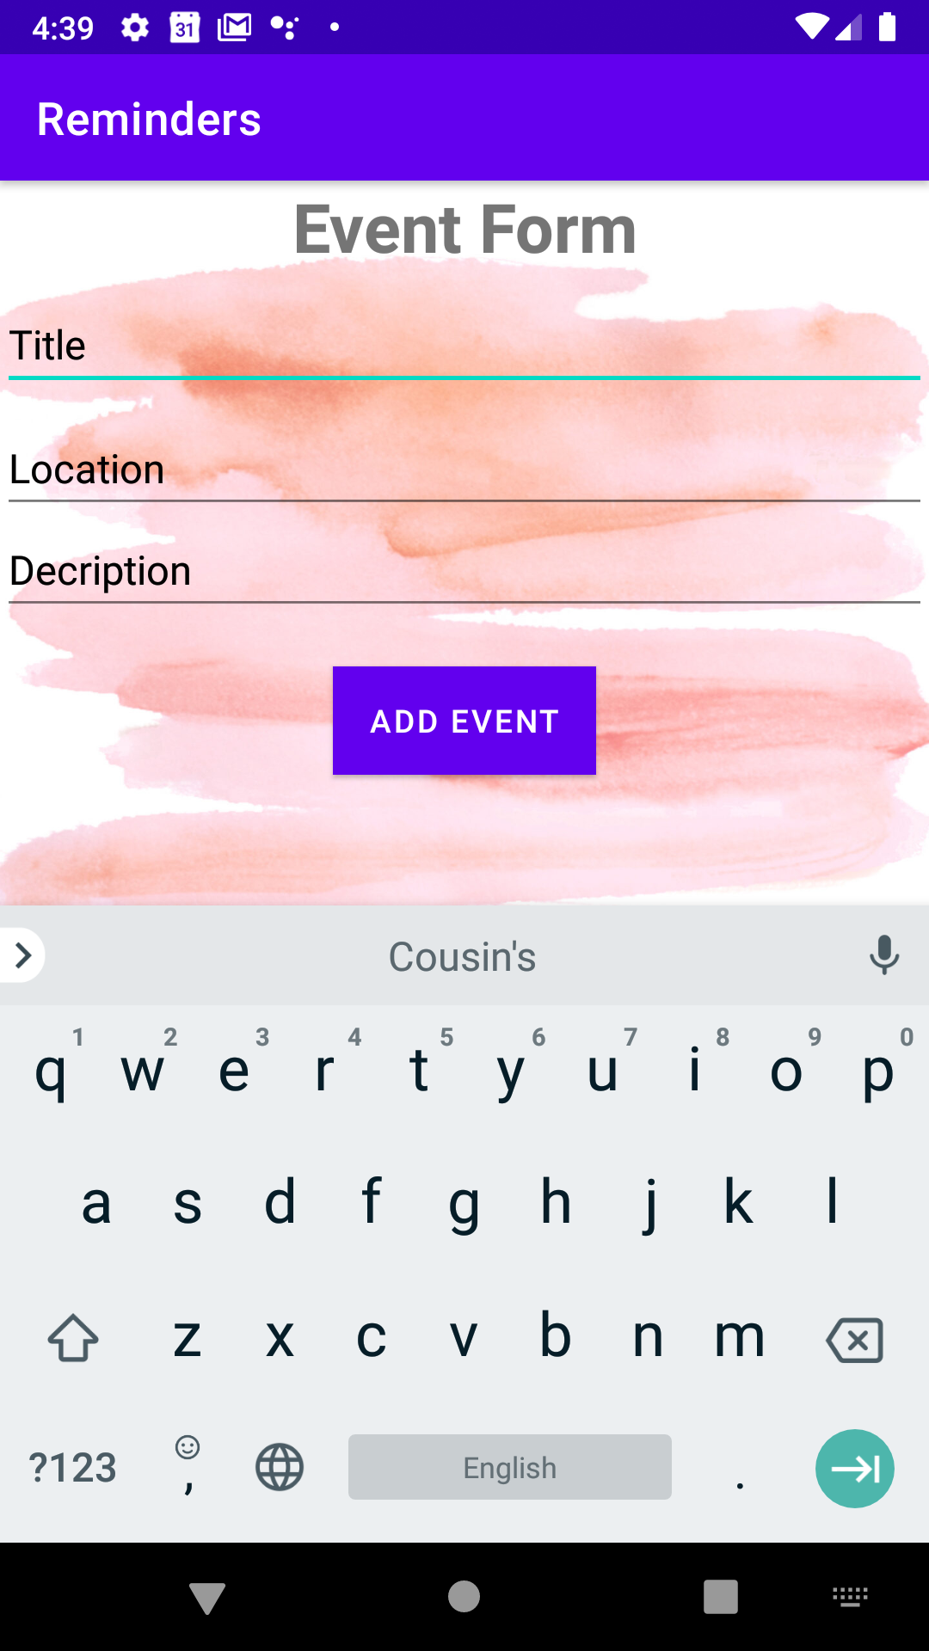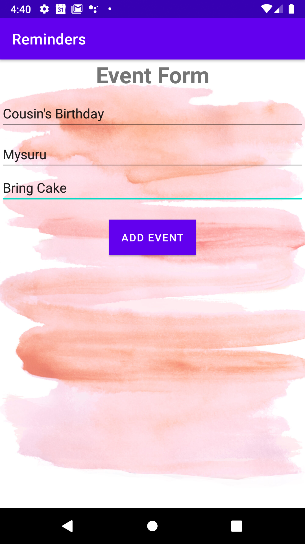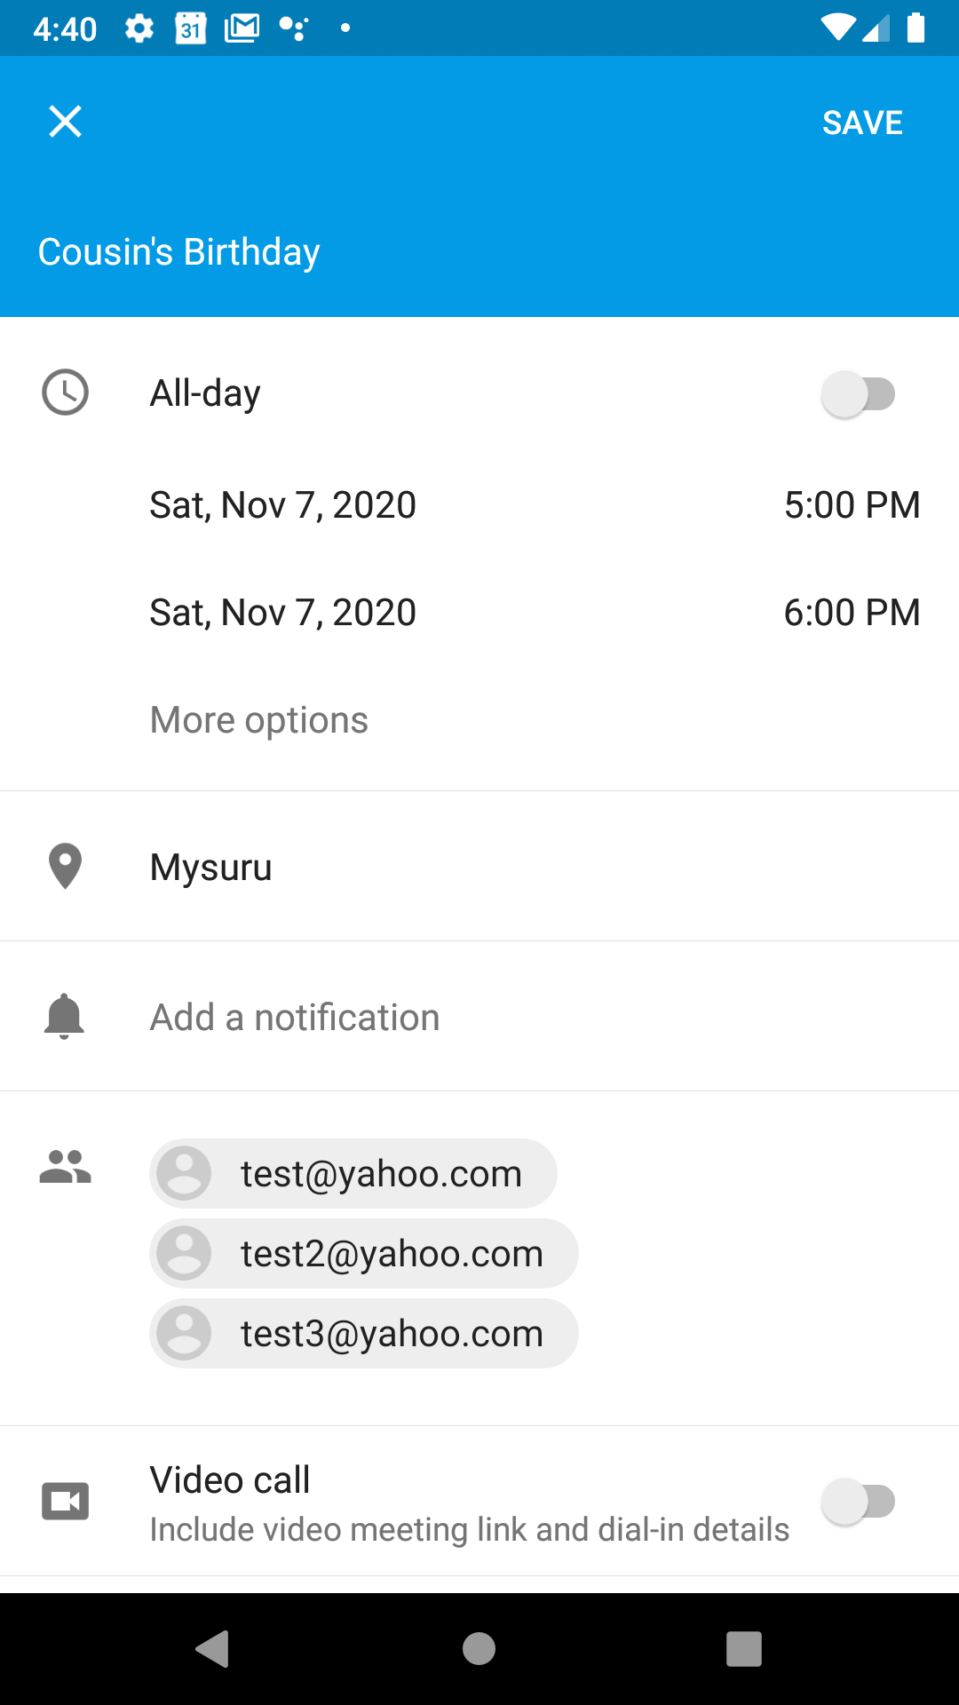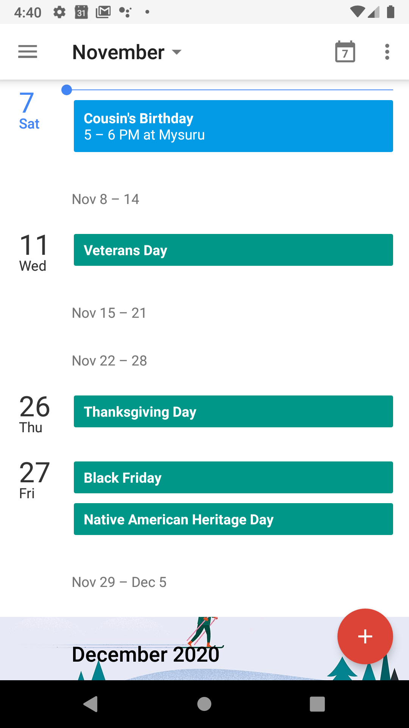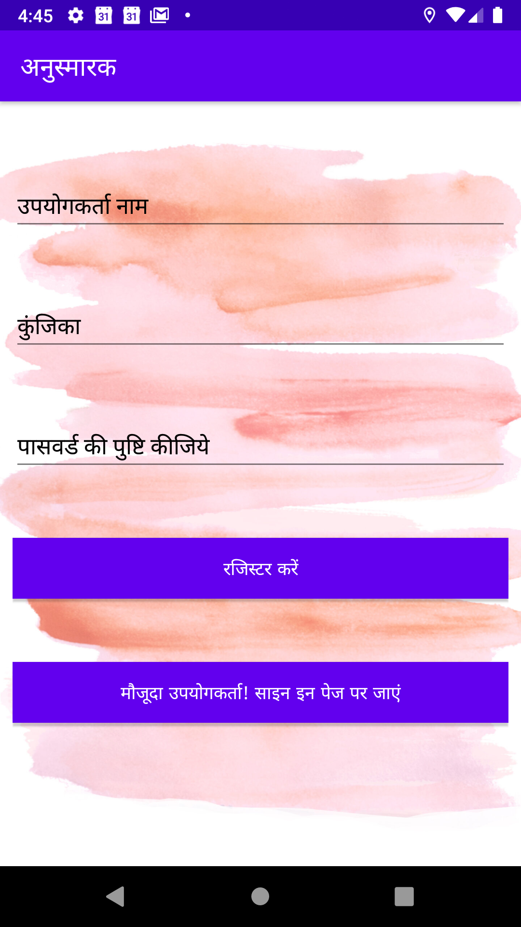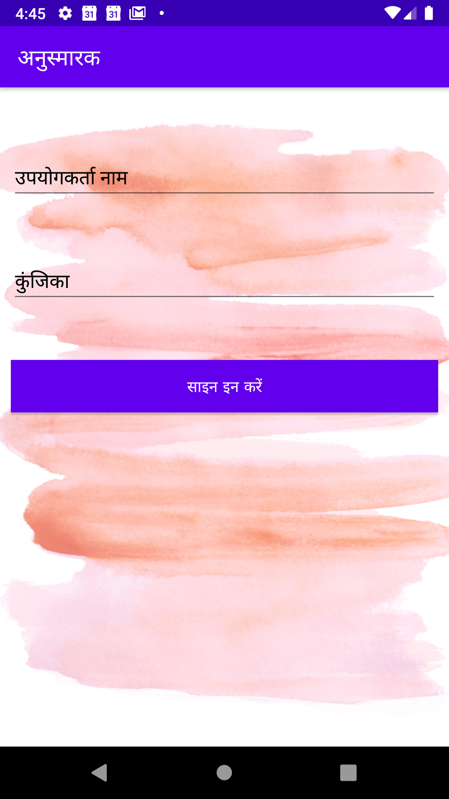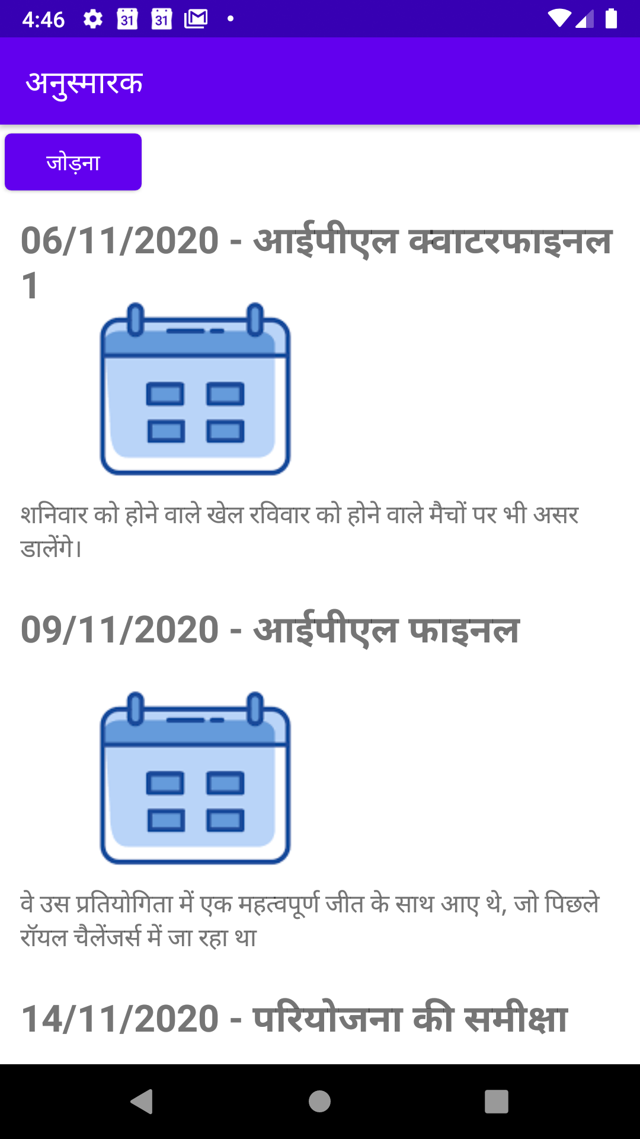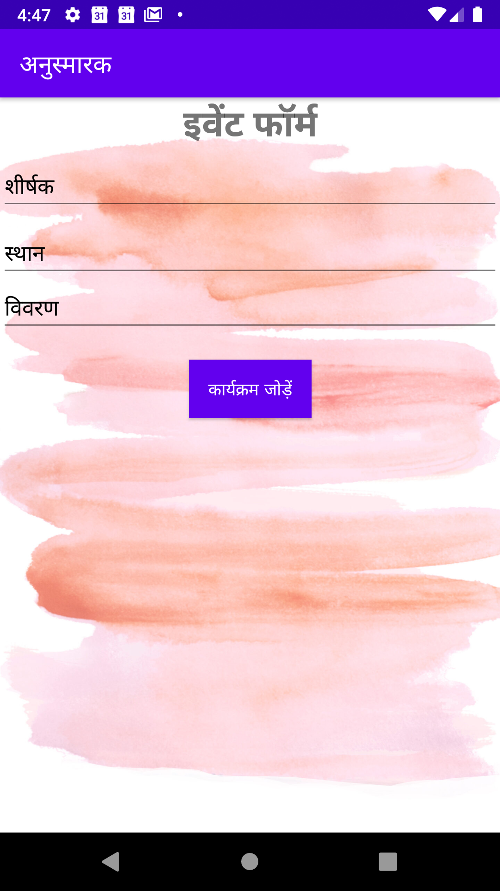

**Links:**

**Online Live Emulator App (appetize.io)** <https://appetize.io/app/mv1b4ybj07k4fcvt90jjjc48xw?device=pixel4&scale=75&orientation=portrait&osVersion=10.0>

**Github Link**

<https://github.com/99002491/RemindersApp>